Pathway to Chartership supervisor agreement

This agreement between the Landscape Institute and [insert name here], Pathway to Chartership supervisor, sets out:

- the person specification and roles and responsibilities of a supervisor
- the financial support provided to supervisors by the Landscape Institute (LI)

Person specification of a supervisor
- Chartered status (CMLI or FLI) for at least 5 years
- Previous and current involvement with the Pathway to Chartership as a mentor and/or examiner
- Excellent written communication skills

Key skills:
- Willingness to act as an ambassador for the Pathway to Chartership and the LI, and safeguard the LI’s reputation and values
- Excellent time management
- Personal qualities:
  - Impartiality, fairness and confidentiality
  - Tact and diplomacy
  - Respect for others
  - Willingness to learn new skills and receive feedback
  - Willingness to speak one’s mind and deal with conflict and issues constructively

Roles and responsibilities of a supervisor

- Review and provide comment on quarterly submissions made by the allocated candidates and their mentors, via the Pathway to Chartership system. The feedback provided should be constructive and supportive, to guide the candidate’s development towards taking the Chartership exam.
- Provide supervisor feedback for between 10 and 25 candidates. Providing feedback to fewer than this may be acceptable, if discussed with the LI first.
- Provide guidance to candidates and mentors on the process and purpose of the Pathway to Chartership, and ways to work effectively, for example using study groups or Talking Landscape.
- Monitor progress of candidates, ensuring early identification of any emerging issues or concerns for the candidate, mentor or the candidate/mentor relationship.
- Review mentor notifications of candidate readiness to proceed to the Chartership exam, and determine, on the basis of candidate and mentor submissions and other information provided within the Pathway to Chartership online system, whether the candidate is sufficiently prepared to proceed to the Chartership exam.

Supervisors also undertake to:
- Provide all feedback within the published supervisor feedback window, and request an extension of time only in exceptional circumstances and within a reasonable time frame.
- Work proactively to ensure that their own knowledge of the Chartership exam syllabus remains current.
- Attend annual supervisor training hosted by the LI. Supervisors are encouraged to attend every training event, but must attend at least every other year. This can be in person, or with advanced notice, remotely, for those unable to easily travel to the training events.
Confidentiality

- The named supervisor agrees to treat as confidential all information provided by their candidates, and the candidates’ mentors during this agreement and after its termination.
- The named supervisor agrees to not to pass details of candidates, mentors or supervisors to any third party without the prior written consent of the LI and the relevant individuals.

Monitoring

Supervisor feedback will be subject to monitoring, by LI staff and/or the chief supervisor, to ensure consistency in feedback between supervisors. New supervisors will have their first two quarters of feedback monitored. Every quarter a random selection of established supervisors’ feedback will be chosen by the LI staff for consistency monitoring. Those supervisors whose feedback has been selected for monitoring will receive feedback from the chief supervisor.

Payments

- Payments to the named supervisor will be made quarterly, based on the number of candidates requiring feedback, as at the last working day of each quarter. The number of candidates allocated to the supervisor will be confirmed with the quarterly payment.
- The LI shall pay the named supervisor £22.50 per candidate submission per quarter. Supervisors will also receive payment if the mentor provides a review even if candidate does not submit.
- Supervisors will not be paid for any candidate where there is no submission from either the candidate or the mentor.
- Reasonable travel expenses to attend supervisor training will be paid separately by the LI, in accordance with the expenses procedure.

About this agreement

- This agreement takes affect from quarter 2 2017 and thereafter supersedes any previous agreement.
- Nothing in this agreement shall create or be deemed to create a partnership or the relationship of principal and agent between the parties, or relationship of employer and employee between the Landscape Institute and the supervisor.
- The supervisor shall have the status of a self-employed person and shall be responsible for all Income Tax liabilities and National Insurance or similar contributions in respect of his or her fees and the supervisor hereby agrees to indemnify the Landscape Institute in respect of any claims that may be made by the relevant authorities against the Landscape Institute in respect of Income Tax or National Insurance or similar contributions relating to the supervisor's services under this agreement.
- The supervisor will be covered for these services under the management liability section of the Landscape Institute’s Professional Liability policy.
- This agreement can be cancelled by either party upon three months’ written notice.

Signed by the named supervisor:

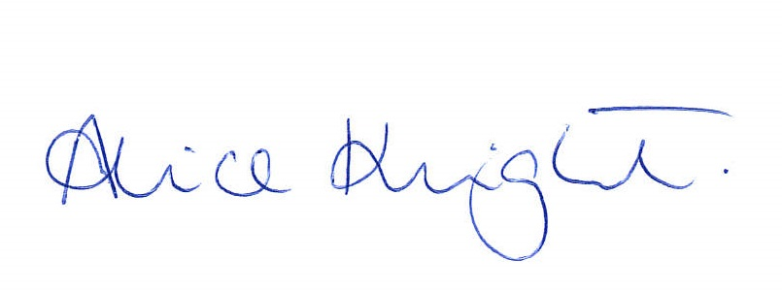
Date:
Signed:
Alice Knight, Professional Development & Standards Officer, on behalf of the Landscape Institute.
Date: 11 April 2017

